**GETHSEMANE UNITED METHODIST CHURCH**

**910 ADDISON ROAD SOUTH**

**CAPITOL HEIGHTS, MD 20743**

**REVEREND RONALD E.F. TRIPLETT, LEAD PASTOR**

**VIRTUAL DISCIPLE/BIBLE STUDY SESSIONS**

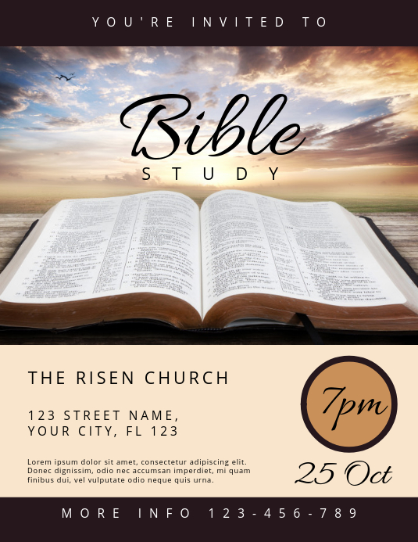

**We cordially invite you to come join us each week as we gather together to glorify God through fellowship with one another and to study God’s word, The Bible.**

**TUESDAY COMMUNITY BIBLE STUDY: “THE END TIMES”**

**Reverend Ronald E. F. Triplett, Facilitator**

**12:00 NOON – 1:00 PM**

**Resources Needed:**

**“The Non-Prophet’s Guide to the End Times” by Todd Hampson (Both Book & Workbook)**

**AND**

**“Genesis to Revelation: A Comprehensive Verse-by-Verse Exploration of the Bible – Ezekiel – Daniel” by Linda B. Hinton**

**To get information of how to purchase the books, please call (301) 336-1219**

**September 21 – December 14, 2021**

***https://zoom.us/j/3013361219***

***Dial In # +1 301 715 8592 US (Washington D.C)***

***Meeting ID: 301 336 1219***