**GETHSEMANE UNITED METHODIST CHURCH**

**910 ADDISON ROAD SOUTH**

**CAPITOL HEIGHTS, MD 20743**

**REVEREND RONALD E.F. TRIPLETT, LEAD PASTOR**

**VIRTUAL BIBLE STUDY SESSIONS**

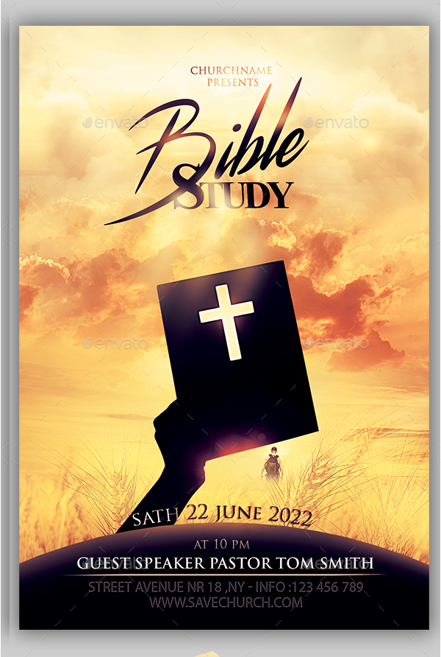

**We cordially invite you to come join us on the 1st and 3rd Thursday of each month as we gather together to glorify God through fellowship with one another and to study God’s word, The Bible.**

**MEN’S BIBLE STUDY**

**Brother Donald Haynes – Facilitator**

**Resources Needed: “Our Daily Bread”**

**To get a copy of “Our Daily Bread” please call (301) 336-1219**

**1ST & 3rd THURSDAY EACH MONTH**

**7:00 - 8:00 PM**

**September 16 – December 16, 2021**

***https://zoom.us/j/3013361219***

***Dial In# +1 301 715 8592 US (Washington D.C) Meeting ID: 301 336 1219***